NAME:S.HANSIKA REGISTER NUM:192421164
ITA0303-MOBILE COMPUTING
4. Mobile IP Application Design for Smart Healthcare (BL4 – Analyze)
Design a Smart Healthcare Mobile IP system using Figma that enables doctors, ambulances, hospitals,
and patients to remain connected while moving across different wireless networks. Analyze:
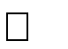

How Mobile IP maintains uninterrupted communication. Challenges during handoff between networks.

Security vulnerabilities during mobility.

Possible design improvements to increase reliability.
Provide navigation between screens demonstrating different mobility scenarios. Deliverables:

Interactive prototype.

GitHub repository containing design files, exported prototype, and documentation.

PROTOTYPE:

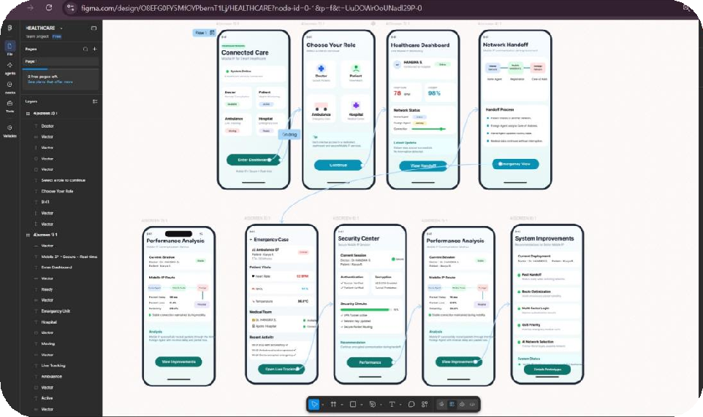

FIGMA LINK:
https://www.figma.com/design/O8EFG0FY5MfOYPbernT1Lj/HEALTHCARE?node-id=6-157&t=ltObzaYgjZgXbQqd-0

5. Wireless Network Decision Dashboard Using GitHub Project (BL4 – Analyze)
Create a web-based dashboard (using HTML/CSS/JavaScript, React, or another programming
framework) or an interactive Figma dashboard that helps network engineers determine whether a given
scenario should use Mobile IP, Cellular Networks, or Ad Hoc Networks. The dashboard should analyze multiple parameters such as:



Node mobility. Infrastructure availability. Network size.



Routing complexity. Energy consumption. Reliability requirements.

The system should justify its recommendation based on the analyzed parameters. Deliverables:
Source code or Figma project.

GitHub repository with complete code/design, README, screenshots, and analysis report.

PROTOTYPE:

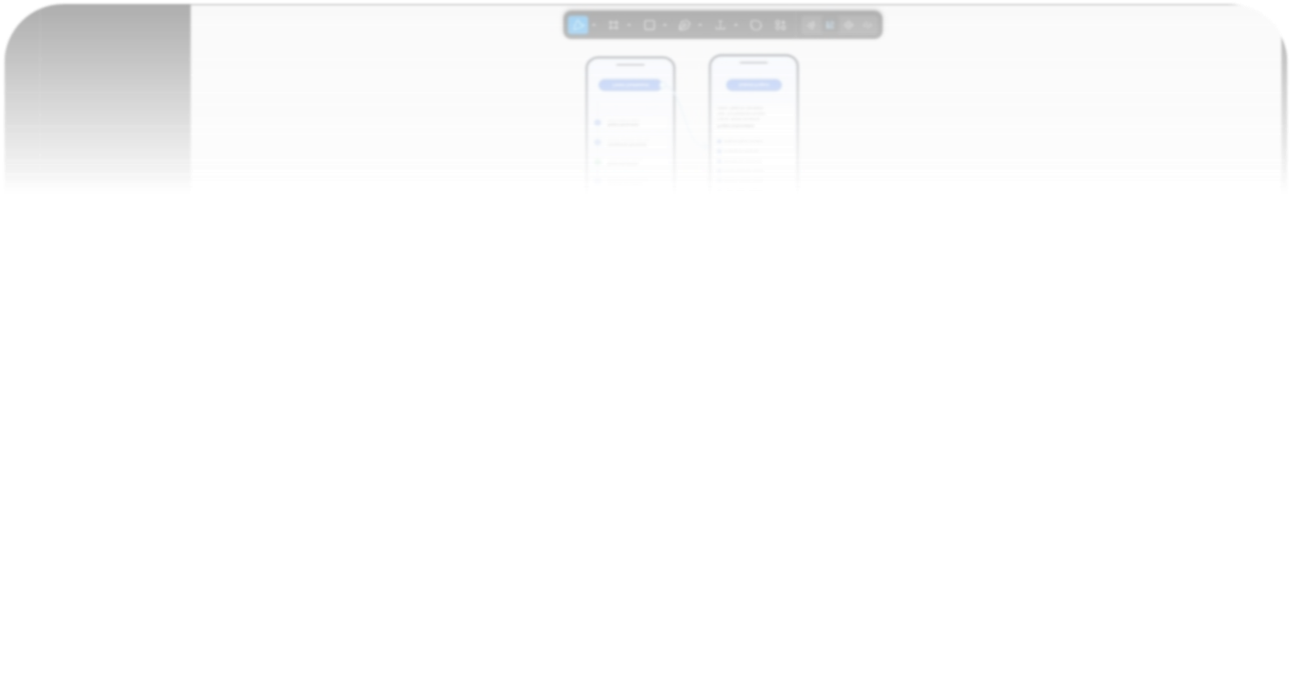
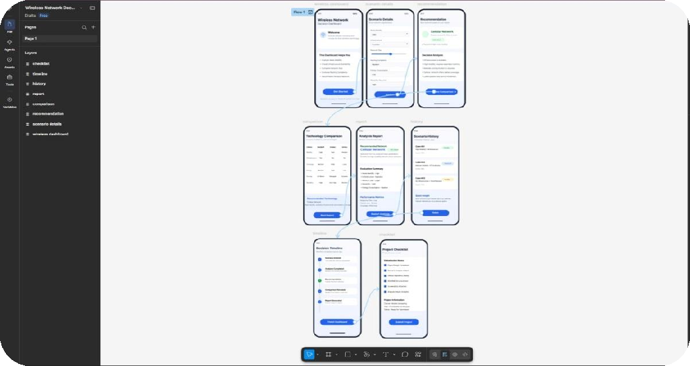
FIGMA LINK:
https://www.figma.com/design/z9dU4gHRBgFm5FFQFu6W5J/Wireless-Network-Decision-Dashboard?node-id=0-1&p=f&t=4bzW6XEC0NA2au7N-0

3. Routing Protocol Visualization and Analysis (BL4 – Analyze)
Develop an interactive visualization using Figma, Mermaid.js, D3.js, or any visualization framework
illustrating the operation of one Proactive Routing Protocol and one Reactive Routing Protocol in a

mobile wireless network. Analyze:
Route discovery process.


Route maintenance mechanism. Routing overhead.


Delay in establishing communication. Performance under high node mobility.
Include a comparative summary explaining which protocol performs better under different mobility
conditions. Deliverables:


Source code/design files.

GitHub repository with implementation, screenshots, and analysis report.

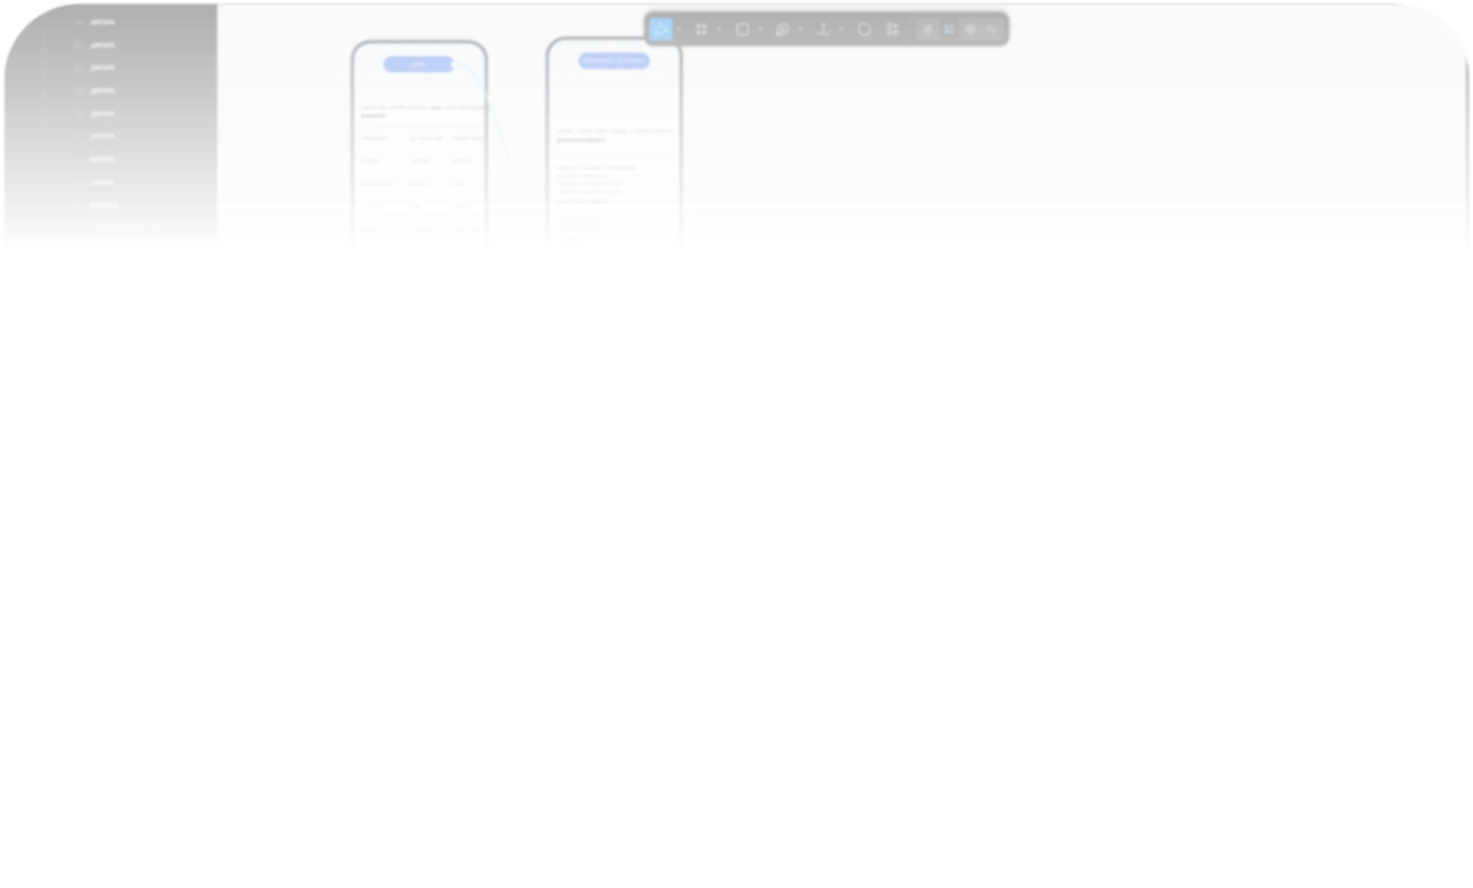
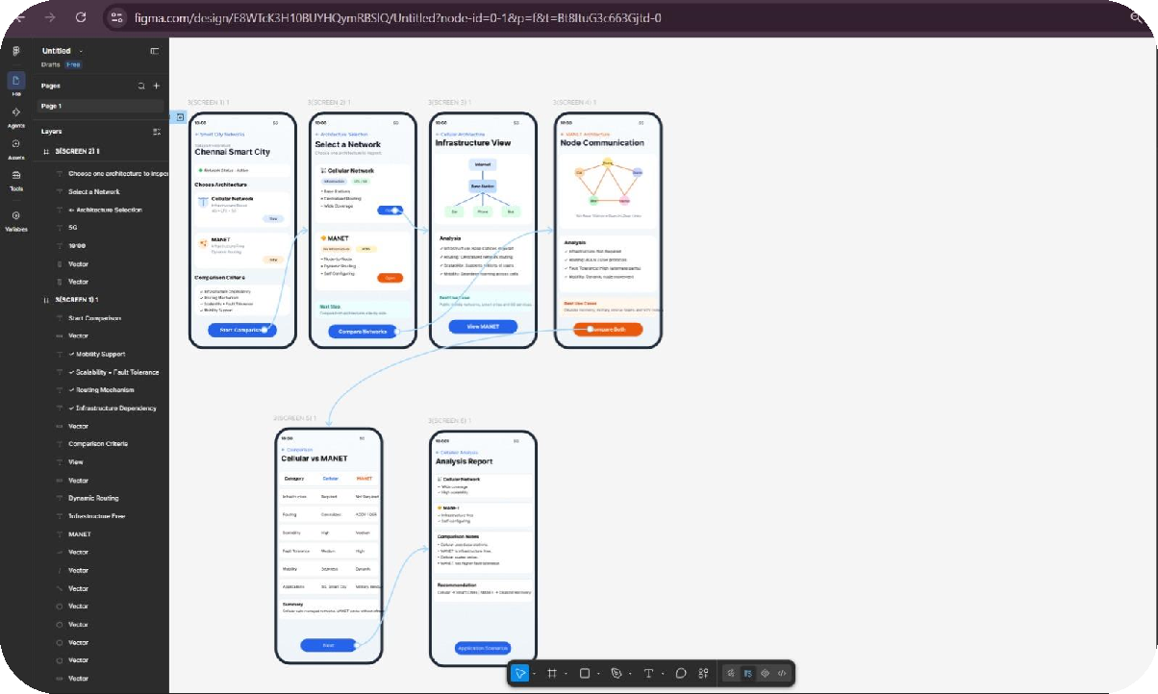
PROTOTYPE:

FIGMA LNIK:
https://www.figma.com/design/E8WTcK3H10BUYHQymRBSlQ/Untitled?node-id=0-1&p=f&t=Bt8ItuG3c663Gjtd-0
1. Figma-Based Mobile IP Communication Workflow Analysis (BL4 – Analyze)
Design an interactive Figma prototype illustrating the complete workflow of Mobile IP communication
when a Mobile Node moves from its Home Network to a Foreign Network. Your design should include
the Home Agent (HA), Foreign Agent (FA), Correspondent Node (CN), Care-of Address (CoA),
Registration Process, and Packet Tunneling.



Analyze the communication process by identifying: The purpose of each network component.
Points where packet delay or packet loss may occur.


The effect of node mobility on communication performance. Possible improvements to reduce latency.
Deliverables:

Figma (.fig) design

GitHub repository containing exported images/PDF and documentation (README).

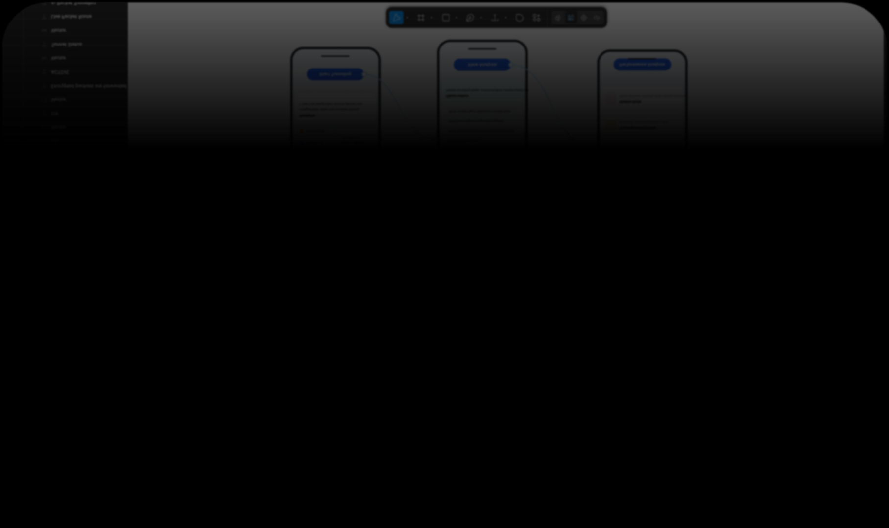
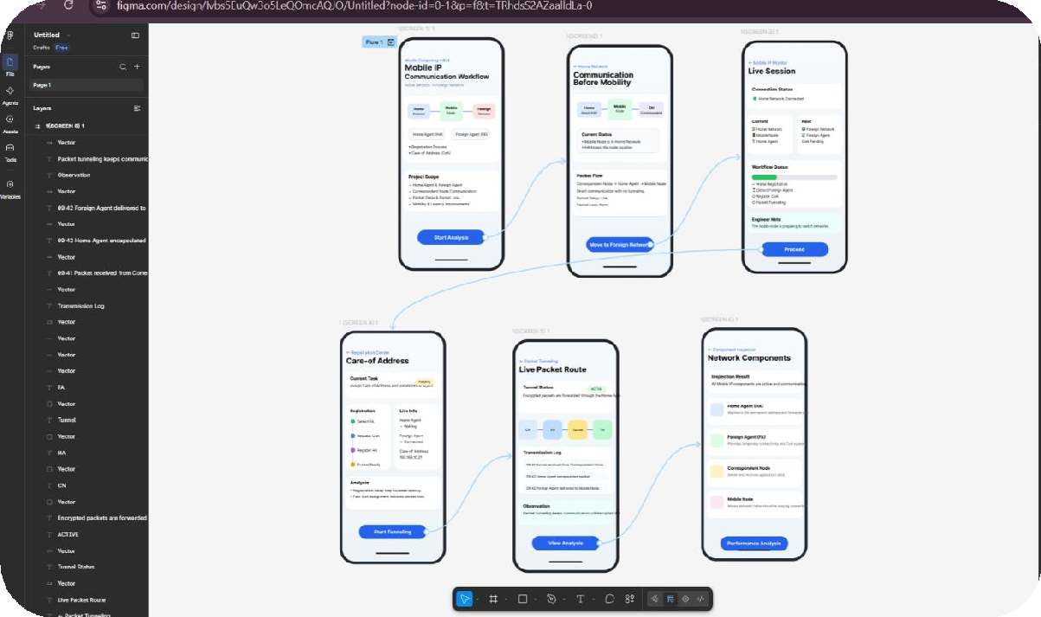
PROTOTYPE:

FIGMA LINK:
https://www.figma.com/design/Ivbs5EuQw3o5LeQOmcAQJO/Untitled?node-id=0-1&p=f&t=TRhdsS2AZaalldLa-0

